October 25, 2021
Ref: IIH/MD/2021/11/006
Awwal Oluwatobi Onaolapo,
21 Plantation Rd, GRA,
Ilorin, Kwara State
LETTER OF APPOINTMENT
I write to inform you of our decision to offer you an appointment to the position of Executive Assistant to the Managing Director at the Ilorin Innovation Hub starting from Monday November 1, 2021. Your annual salary will be N600,000 (Six hundred thousand naira) after tax. Your job description and responsibilities will be communicated on acceptance of this offer.
Kindly respond with your acceptance in writing by Friday October 29, 2021.
We are starting exciting new ventures in Ilorin and are looking forward to working with you to make our dreams a huge success.
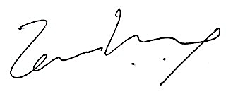
Yours sincerely,

Temi Kolawole
ag. Managing Director
Ilorin Innovation Hub

